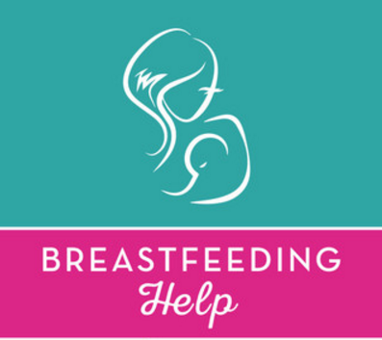

The following are breastfeeding resources available in our community. We encourage you to explore these options if you would like help with breastfeeding, beyond what your midwife is able to provide.

Breastfeeding Buddies
- a peer-focused support group for breastfeeding moms in Perth County
- meets the first Thursday of each month at the Stratford Early Years Centre (35 Waterloo St. North in Stratford)

St. Mary’s Hospital Breastfeeding Clinic 519-284-1332 ext 3365
St. Mary’s, Ontario
- free of charge
- available from birth until 4 weeks of age
- staffed by registered nurse and lactation consultant, Gail Smith
- drop-in Clinics Tuesdays 6pm to 10pm and Thursdays 9 am to 1 pm

Stratford General Hospital Breastfeeding Clinic 519-272-8210 ext 2901
- free of charge
- available from birth until 4 weeks of age
- drop-In Clinics Mondays 10:30am to 1pm and Wednesdays 9am to 1pm

Carol Hamilton 519-272-0441
- private lactation consultant in Stratford
- offers consultation at her office at a rate of $90/hour or in your home at a rate of $120/hour
- has hospital-grade breastpump available for rent

Tanya Chambers 519-273-9200
Stratford, ON
- chiropractor who also has training in breastfeeding support and offers breastfeeding consultations.
- fee

Dr. Jack Newman www.ibconline.ca
Toronto, ON
- a pediatrician and expert in breastfeeding
- lots of great videos and information on his website (www.ibconline.ca)
- runs a breastfeeding clinic in Toronto with expertise in helping with particularly challenging cases
- provides lip and tongue-tie releases
- referral from your midwife is required – just call the office and we will gladly provide the referral.
- appointments last 60-90 mins and have a fee of $73.45 per appointment

